

VILNIUS UNIVERSITY
ŠIAULIAI ACADEMY
BACHELOR PROGRAMME SOFTWARE ENGINEERING

Computer networks laboratory work No. 4

Student : Hanna Asiadouskaya
Lecturer: dr. Nerijus Ramanauskas

Šiauliai, 2024

- 192.168.0.131
- Value in upper layer protocol field is 1
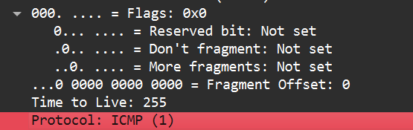
- As in there 20 bytes in the IP header and the total length is 56 bytes, then in the payload would be 36 bytes.
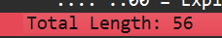
- The “More fragments” flag is set to 0, that means that the datagram has not been fragmented.
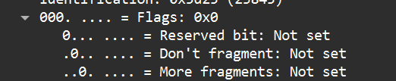
- The header checksum, Time to Live and the Identification always changes.
- Stay Constant:
- Version because we are using IPv4 for all packets
- Length of the header because we are using IPv4
- Source IP since my computer’s IP address doesn’t change
- Destination IP as usc.edu’s IP address doesn’t change
- Differentiated services as there the same protocol every time
- Upper Layer Protocol since these are ICMP packets
Must stay Constant:
- Version
- Length of the header
- Source IP
- Destination IP
- Differentiated services
- Upper Layer Protocol
Must Change:
- Identification because IP packets must have different ids
- Time to live as it is increments with each packet
- Header checksum, as header also changes.
- The pattern in the identification field is that the field increases by one with each ICMP Echo request.
- Identification: 0xdb6f (56175); TTL: 1
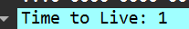
- The Identification field changes from all of the replies because this field has to have a unique value. However, TTL field remains the same because the TTL for the first hop router is always the same, and equals 1.
- This packet has been fragmented across more than one IP datagram, but wireshark grouped them together

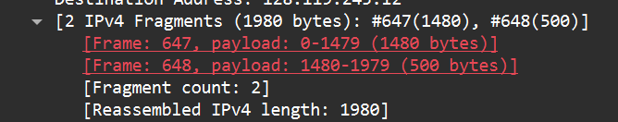
- 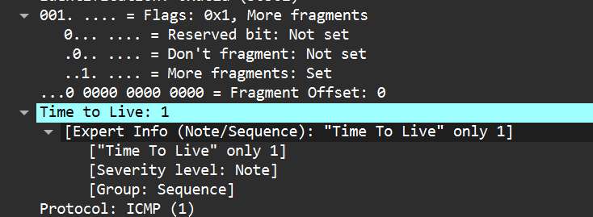
The fragment offset is 0, and the more fragments set flag is 1, so we know that this is the first fragment. The first datagram has a total length of 1500, including the header.
- 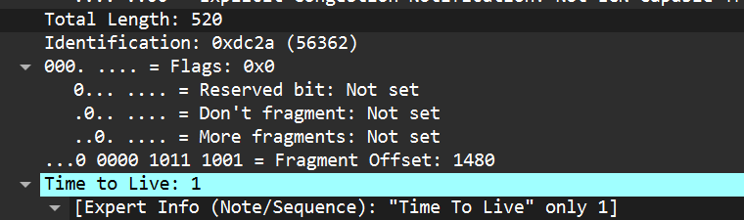
The fragment offset is 1480, and the more fragments set flag is 0, so we know that this is the last fragment.
- Total length, flags, fragment offset, and checksum are fields that changed.
- After switching to packet size of 3500 3 packets are created from the datagram
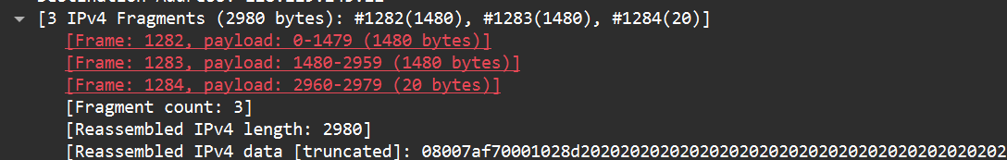
- The IP header fields that changed between all of the packets are fragment offset and checksum.

